**CNET PROJECT**

**By: Malaika Saleem 22i-0509 AIC**

**TOPOLOGY:**

I designed the topology according to assigned in which I used routers,switches, servers,laptops, smartphones, tablets,PCs and link wires.

**TREE:**

I made the tree according to my Private Ip and number of hosts in each network.

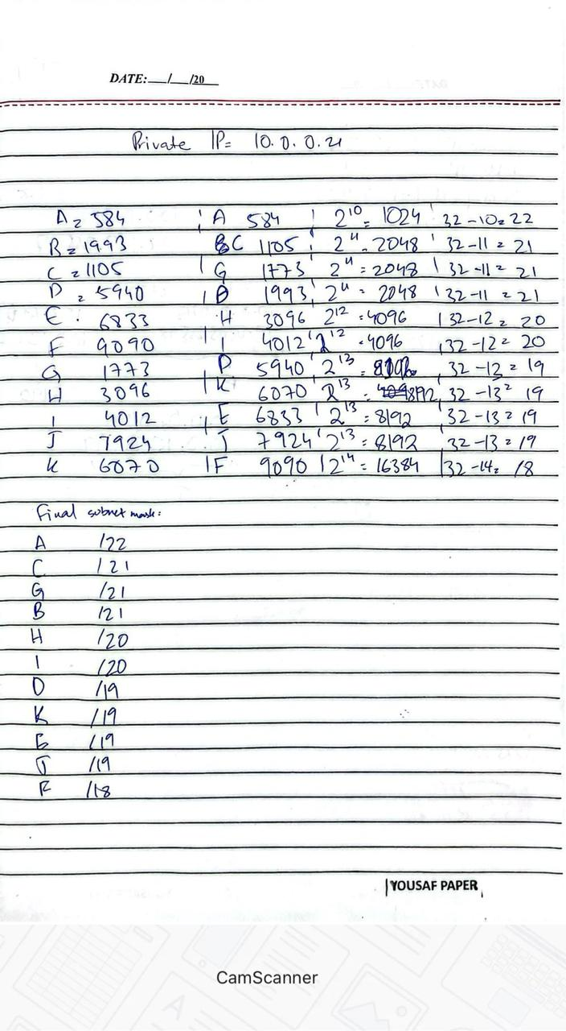

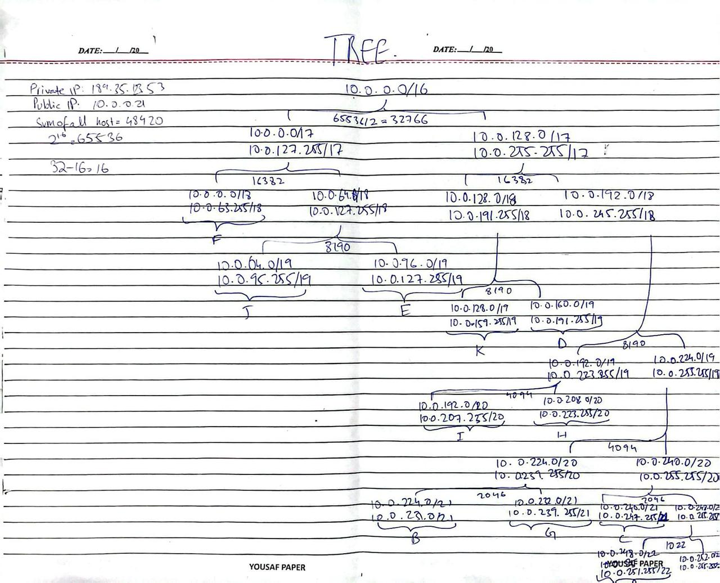

**IP ASSIGNMENT:**

1. **ROUTER TO SWITCH:**

Assigning Ips to router for router to switch links based on the Ips assigned to network in VLSM tree

1. **ROUTER TO ROUTER:**

Assigning ips to router after dividing the VLSM till the first 23 /30.

**ROUTING:**

First do routing based on the block-wise assigned routing technique and then perform redistribution on all the connecting routers (in my case 3 routers).

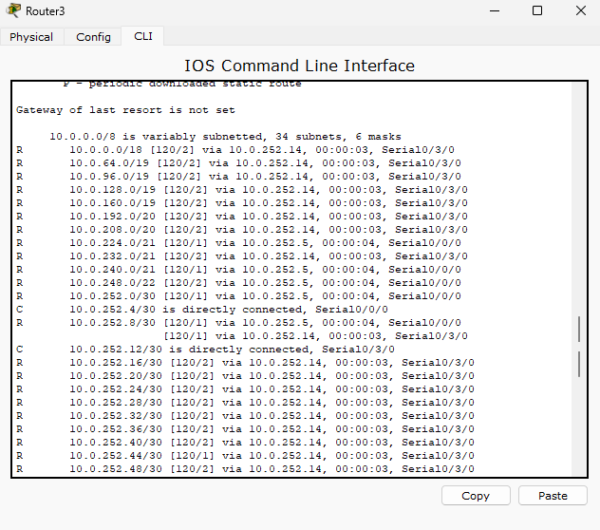

REDISTRIBUTION:

Performed redistribution in following method:

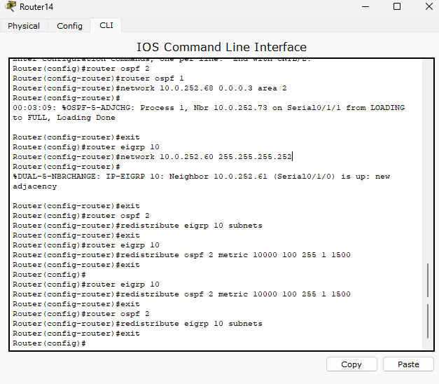

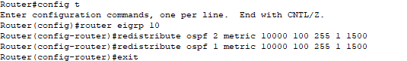

DHCP:

Performed DHCP in following method:

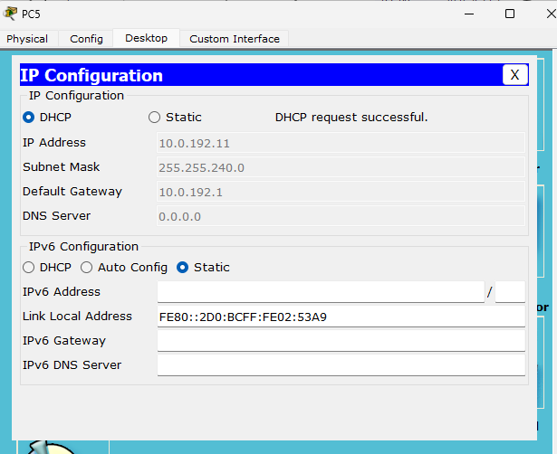

After applying DHCP: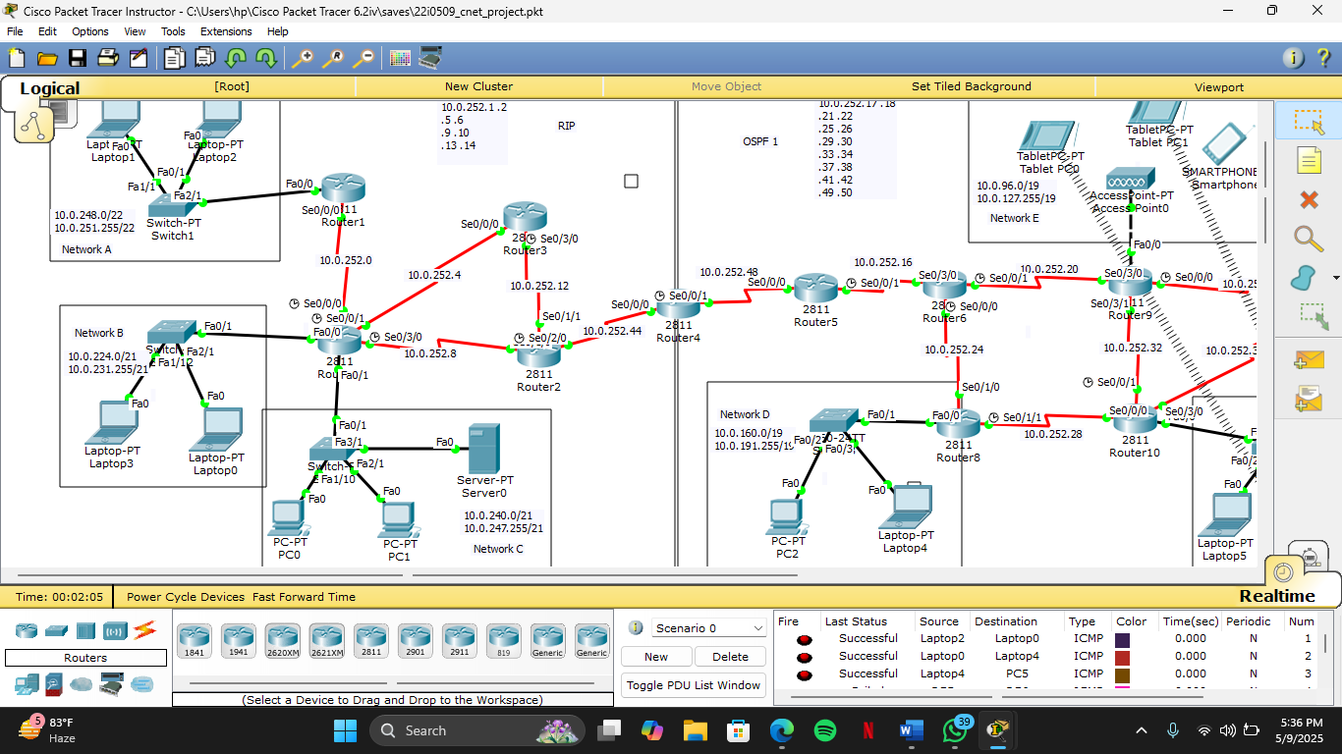

NATing:

Performed NATing in following method:  
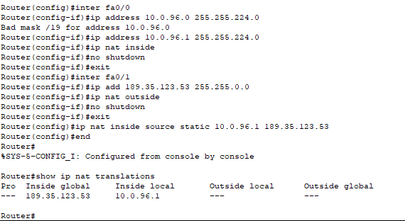

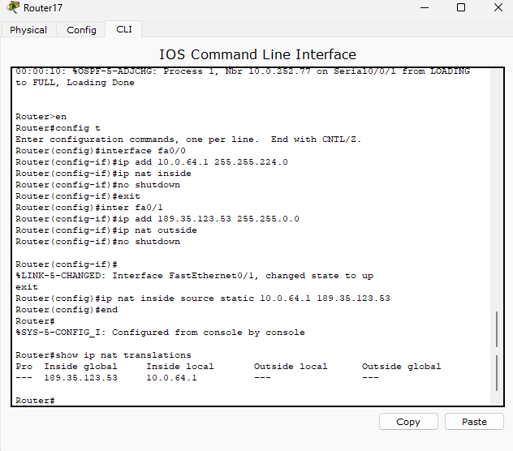

ACL:

Performed ACL in following method:

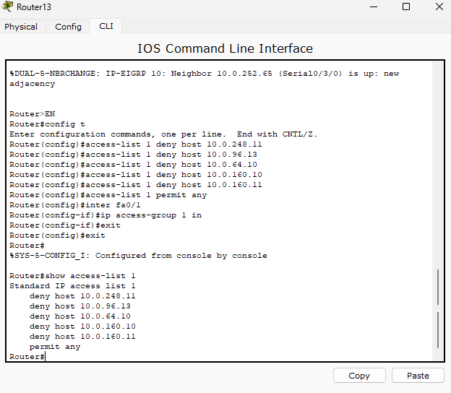

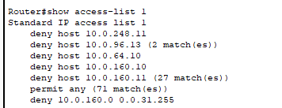

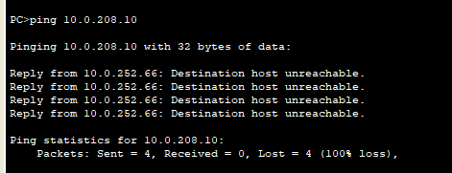

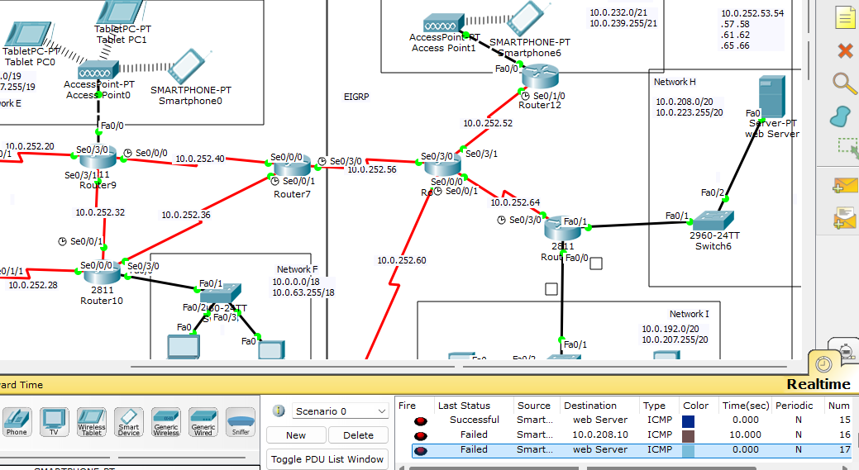

EMAIL CONFIG:

Configured email in following method:

